After I tested my CSS stylesheet, I had some work to do in order to make the homepage function.

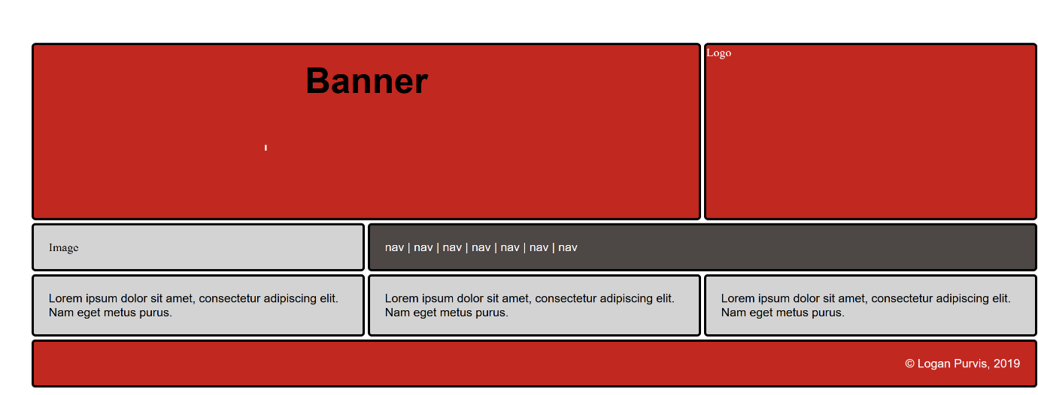

The first thing I did was to add the colours from my wireframe to the webpage and add some text in the main-nav section to indicate this is the home-page.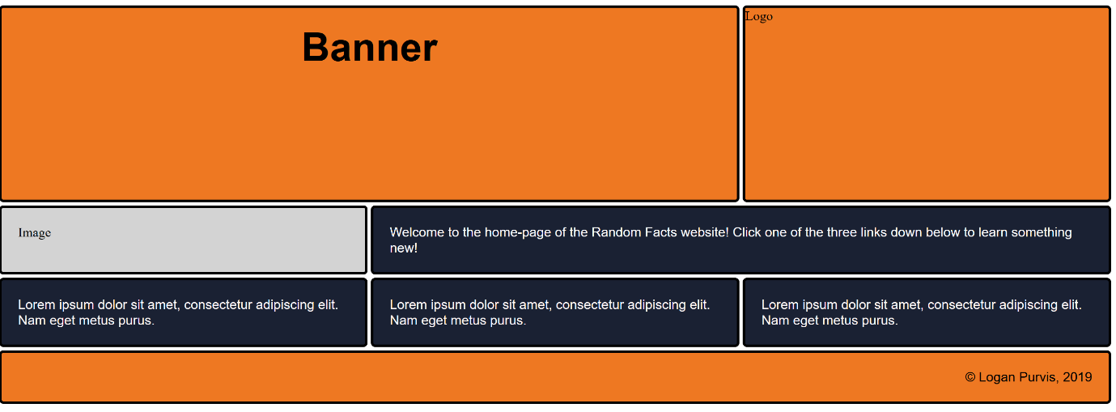

Next, I added the banner text and logo. The size was a bit off, so I changed the size to suit the grid format.

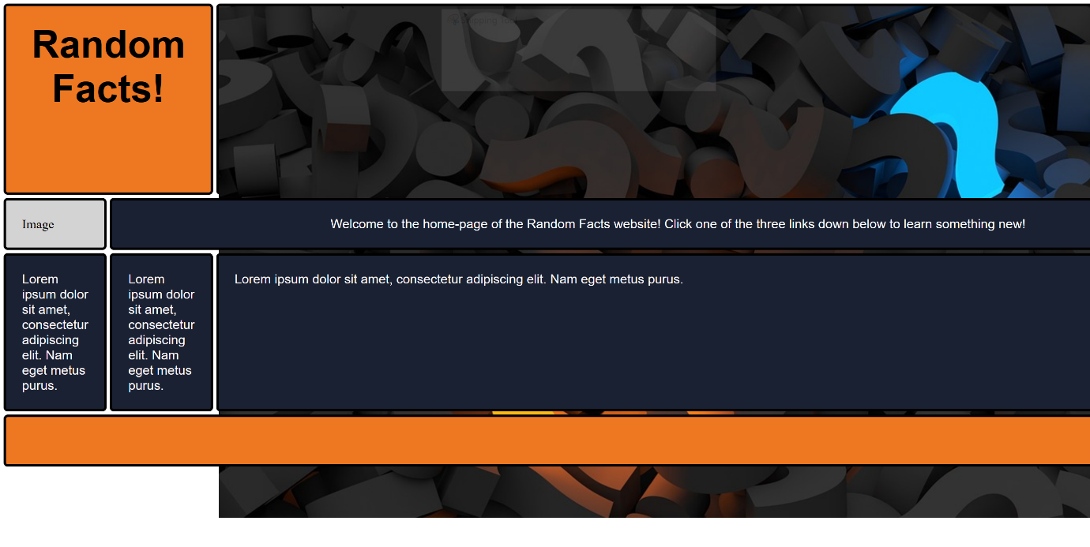

After a fair amount of editing, I managed to get the picture almost perfect. I need to increase the size a tad more to fit the grid.

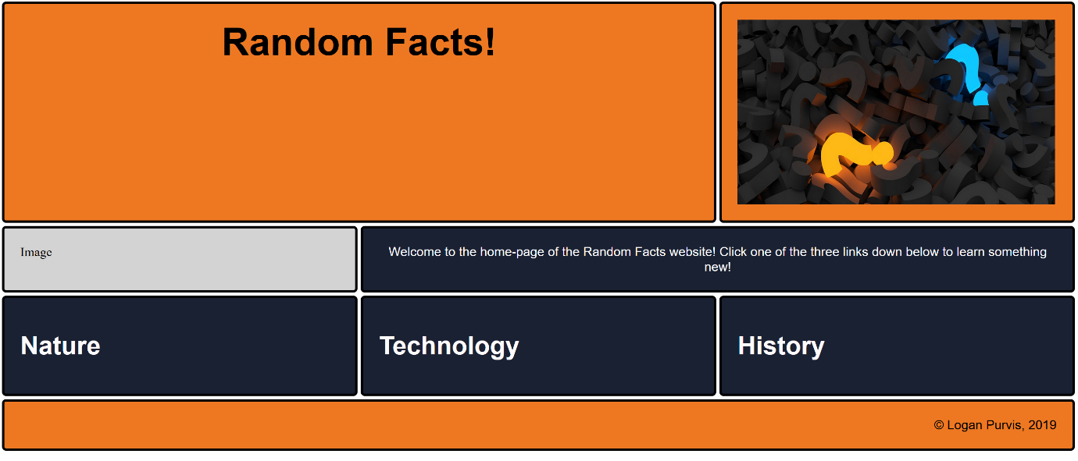

On the corners of my webpage, my corners were square. I rounded them out to give my website a more visually pleasing touch. (Border radius of 5px)



This is the end result of my rounded corners.



My headers for each 'fact section' were far too big. I reduced their size in order to fit more on the page and make the text blend with other elements better. (Reduced the h1 to h2)

BEFORE



AFTER



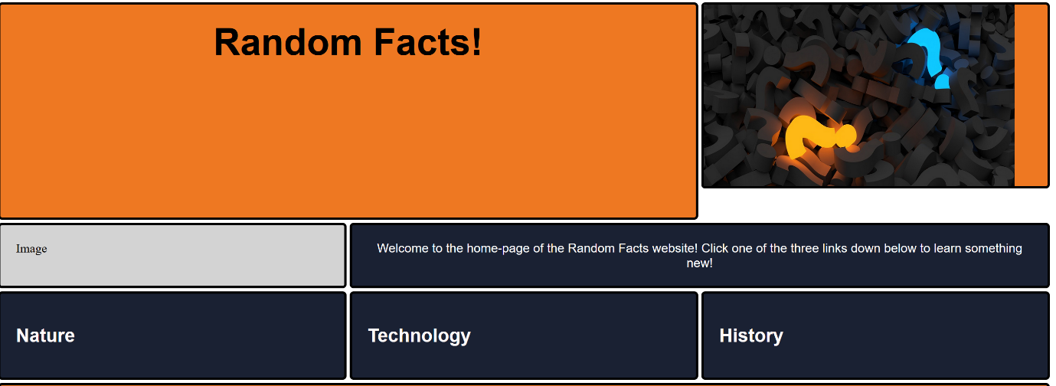

Adding the background image (through CSS) to the 'Nature' section was not difficult. The only standing issue is the size of the image, which will eventually be changed.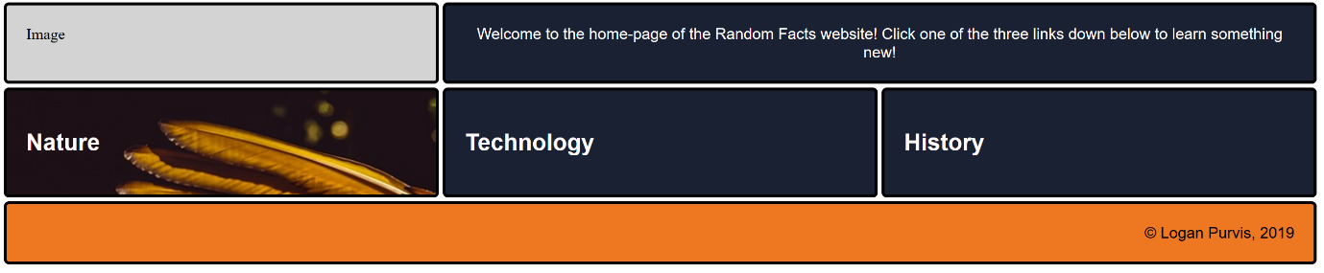

I changed the size of the background to 500 pixels. This means there is more room for text and a link to go below the header.

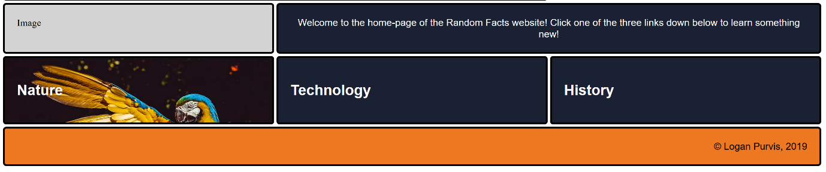

To help with my aesthetics implication, I have imported three google fonts and used CSS to modify the look of the text when used as a hyperlink, which I set as the entire div so that the image can link the reader as well. This helped to refine my website's look and functionality.

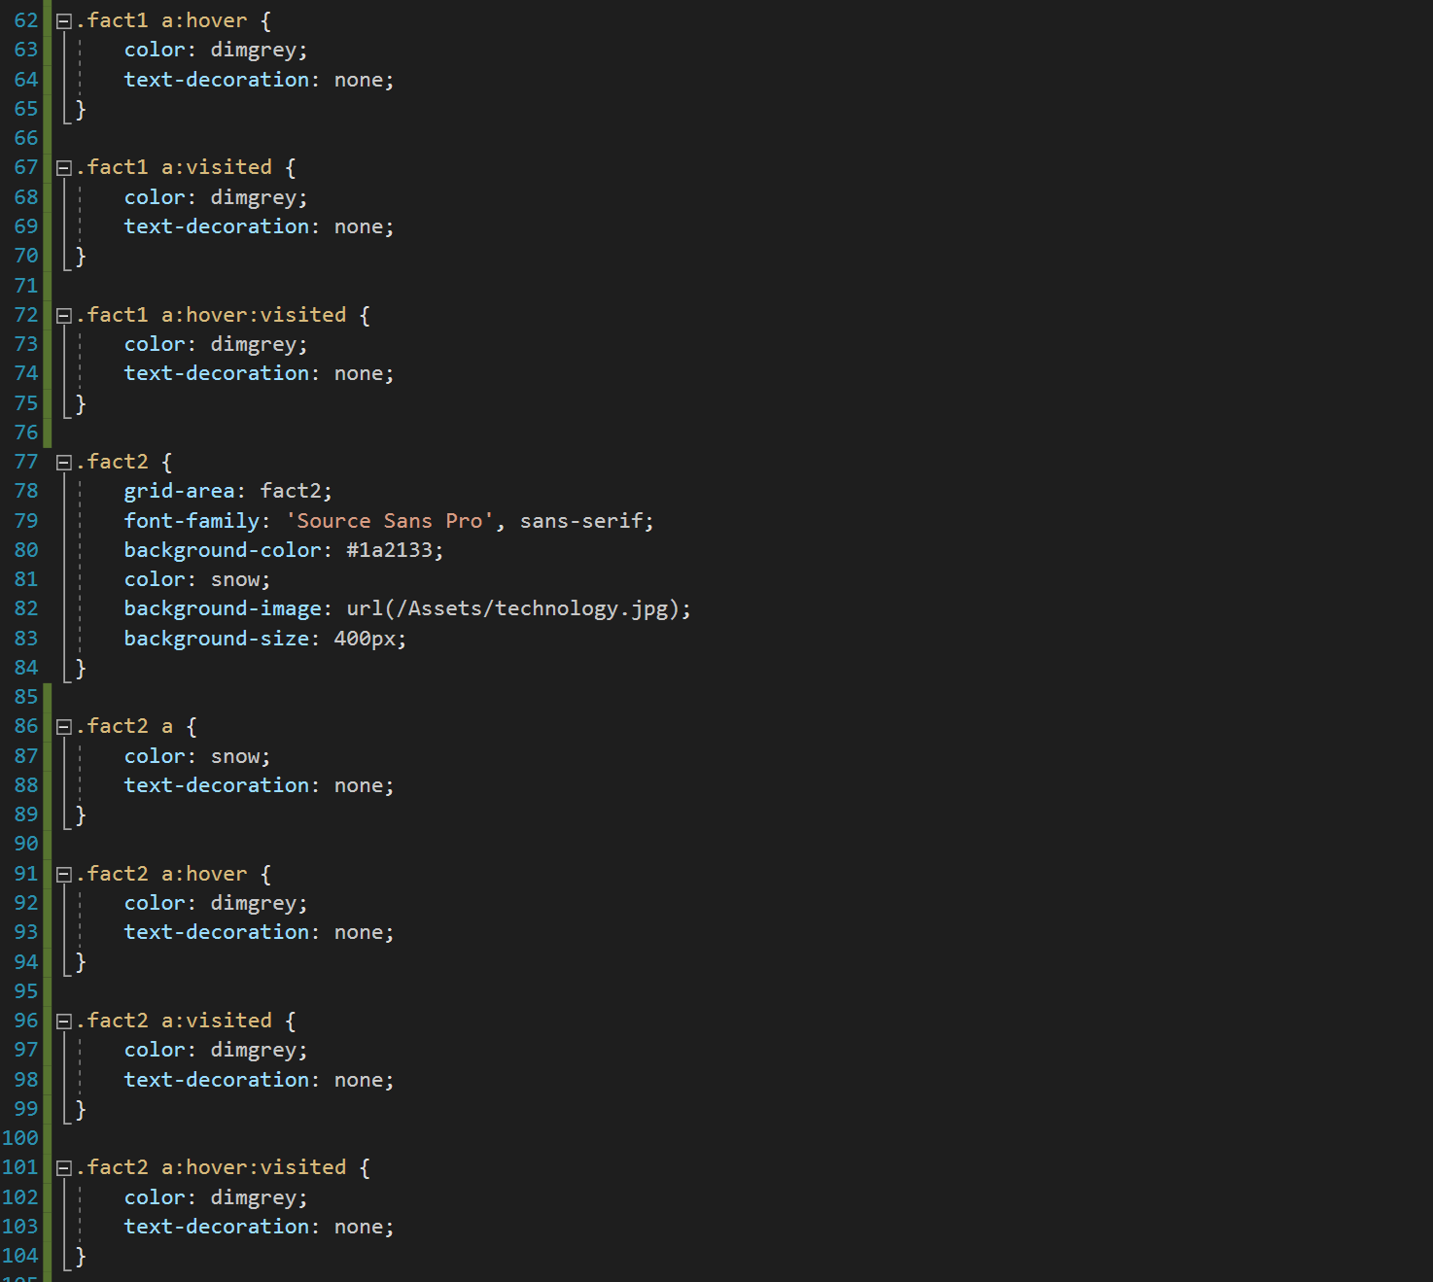

After some consideration and future planning, I decided to use an internal stylesheet for my background image as I would be changing them on each webpage.

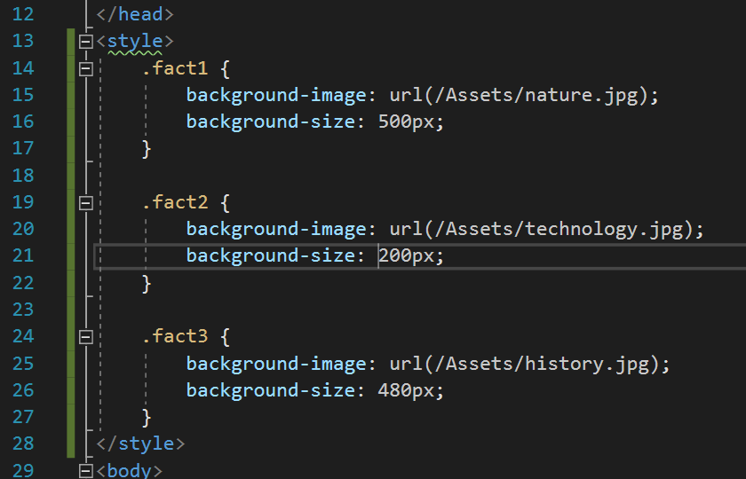

After some testing, I changed the background size on the 'fact 2' div to 350 pixels. This made the image fit the page more.

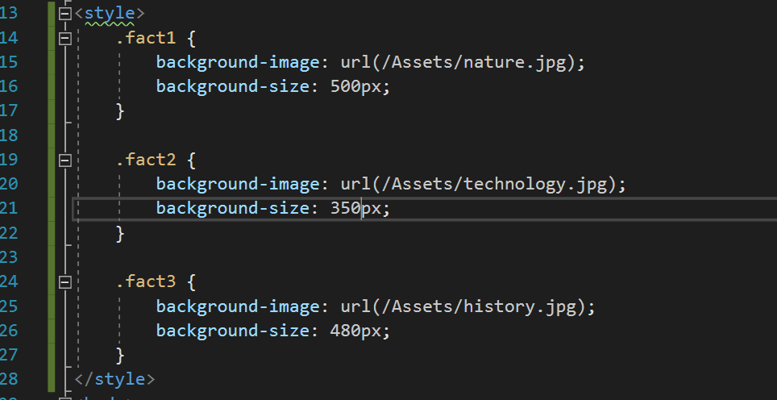

The next big objective for me was to create a second page. I did this through a web form.

Using 'includes' to prevent me from repeating my header and footer code really saved me a lot of time and refinedmy outcome.

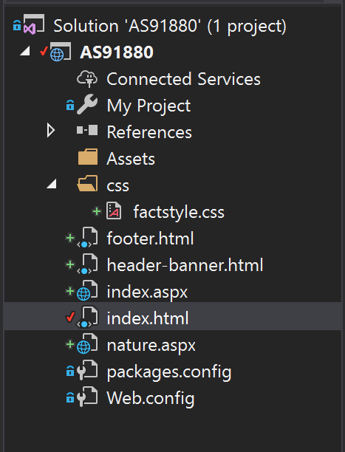

I then proceeded to delete the 'index.html' file since it was no longer needed. (I have an .aspx file to replace it.) I set the new web form to be the start page.

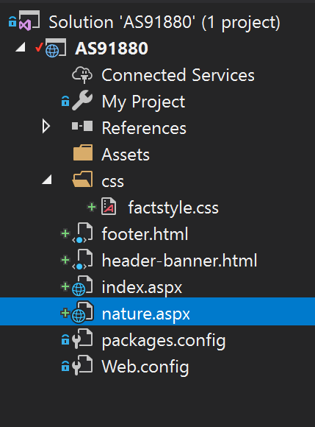

After a fair amount of consideration I decided to remove the dedicated 'image' box was no longer necessary. I changed it into a 'navigation' panel to improve ease of access between my pages. I removed the 'null' text and changed it into a more fitting description.

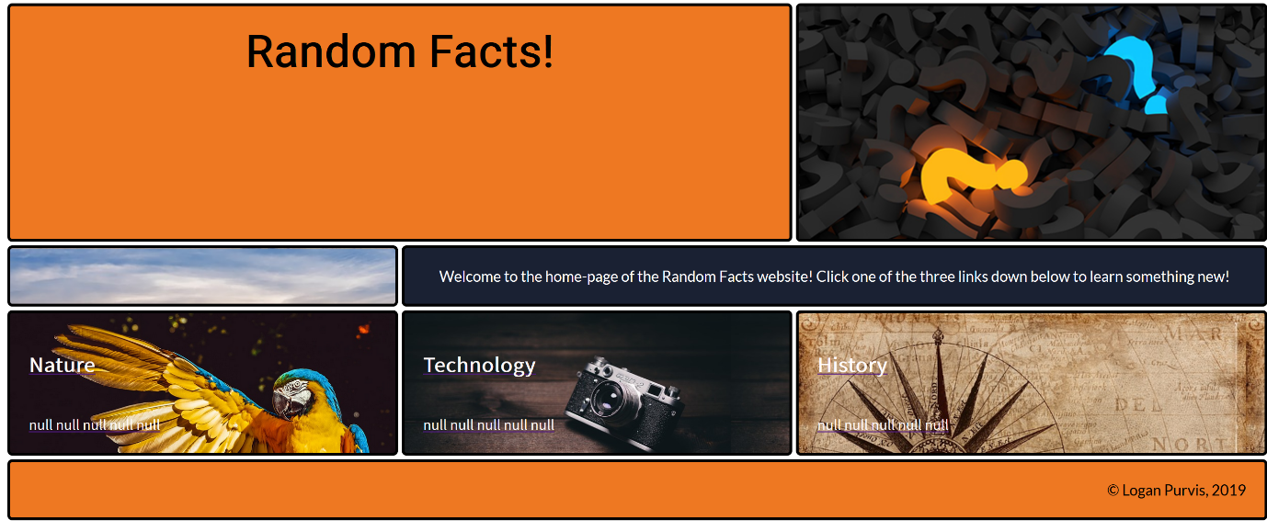

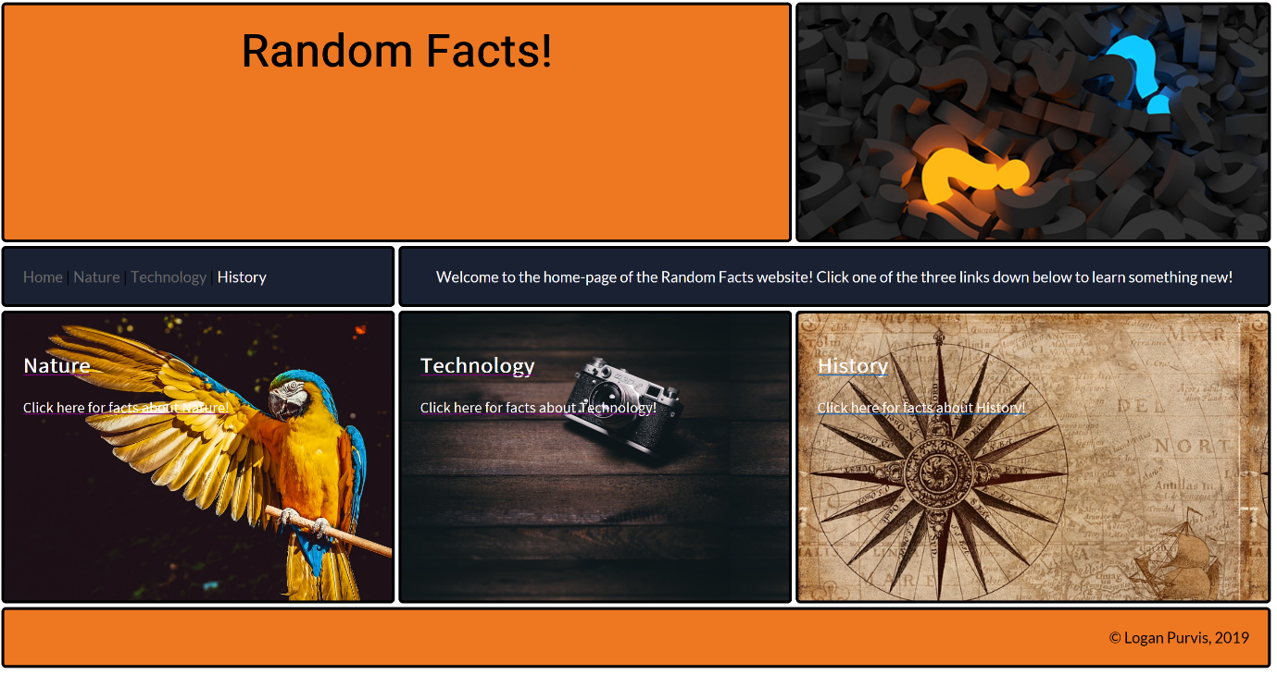

The 'index' page was complete. I validated my code, and all was well.

Onto the 'nature' page. I copied all code from the 'index.aspx' page and edited it to suit the new page.

The first thing I had to do was to find 3 facts. I found them and placed one in each box. I then added a level 2 header to refine my website and make it easier for readers to read text.

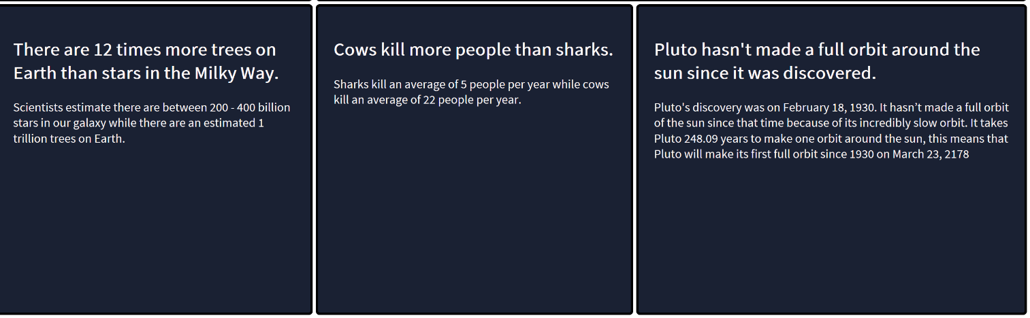

 I added an image for each fact, relating to the fact itself. This required a bit of testing to find the precise size for each image so this took a while. The first time I added the image, they were cut off and in different sizes. After a lot of fiddling, I managed to refine the look of the page.

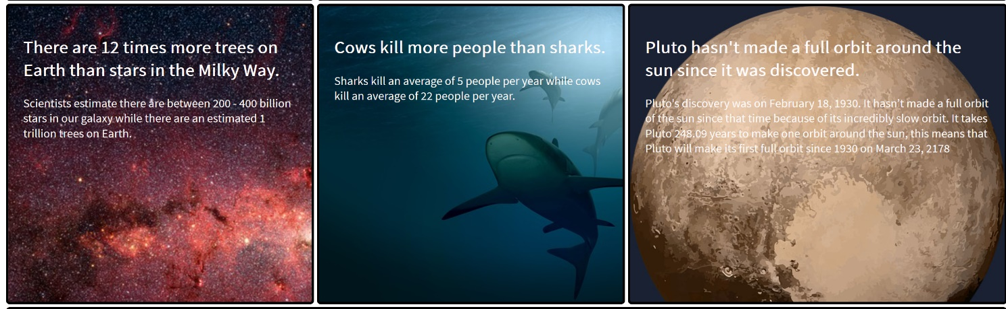

The nature page was done, so I moved onto the other pages: Technology and History.

I found the facts and proceeded to fit images. This, once again, took a lot of time to perfect.

 TECHNOLOGY HALFWAY:

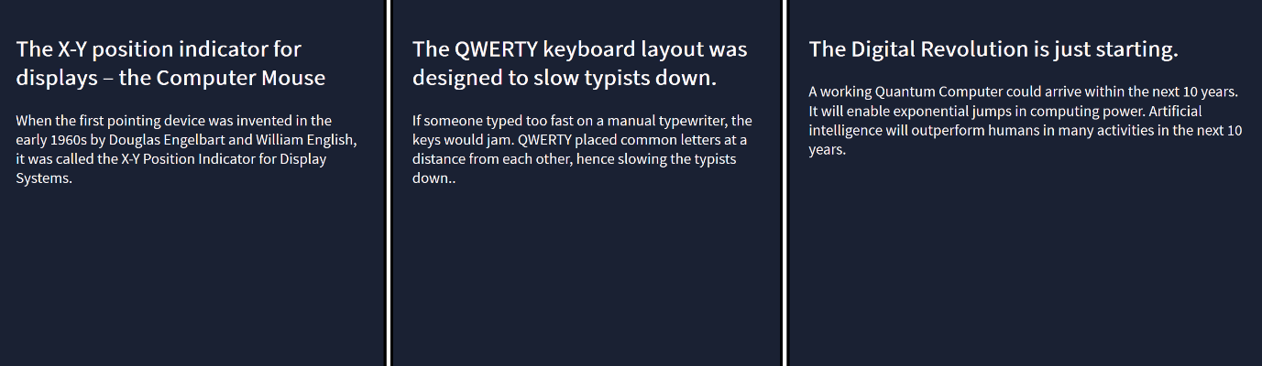

TECHNOLOGY FINISHED: 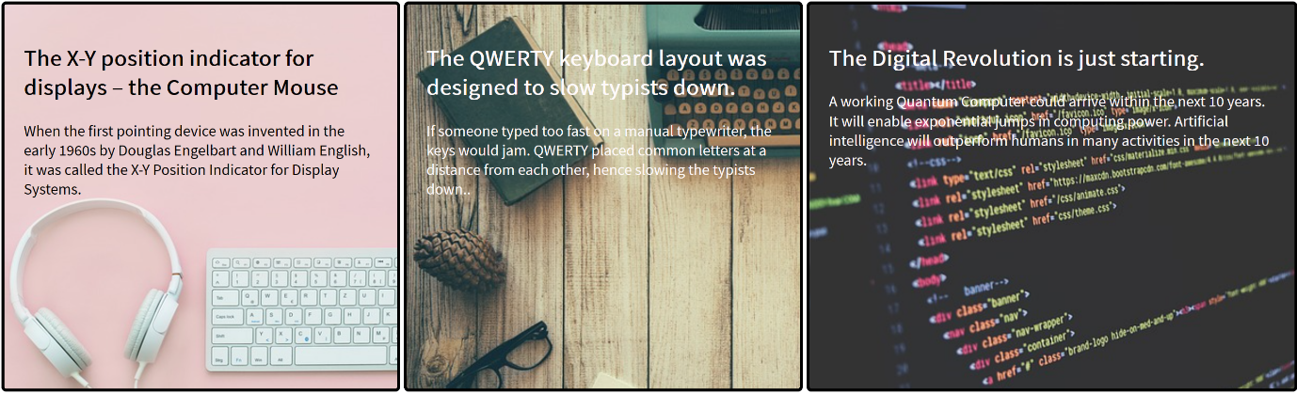

HISTORY HALFWAY:

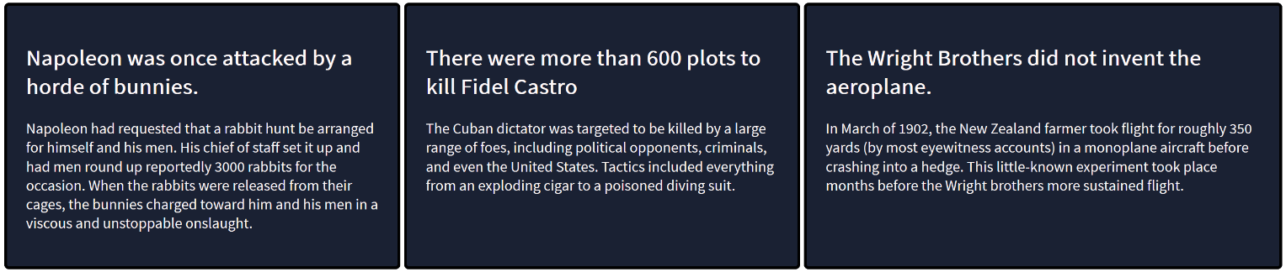

HISTORY FINISHED:

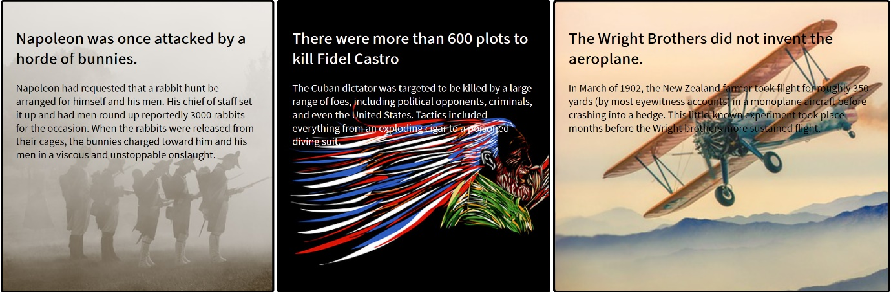

I noticed that some of the text on my final 'History' and 'Technology' pages was hard to read. I set out to fix that using Photoshop. I also ended up changing the third picture so that it looks better with the rest of the site.

 BEFORE:

 AFTER: 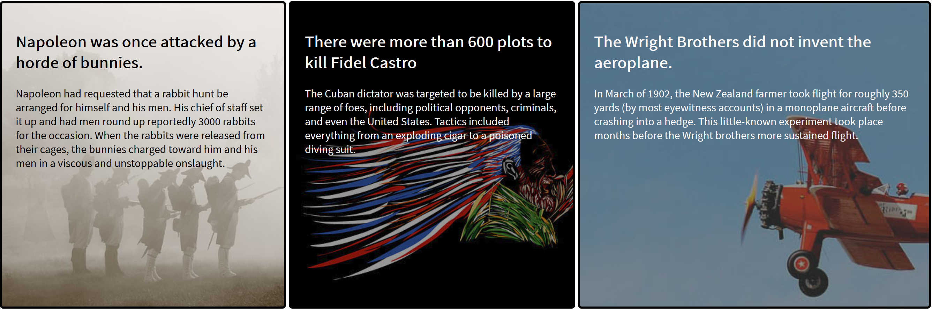

One of the last things I had to do was insert my email address in the footer in case someone wished to contact me.

BEFORE:



AFTER:



Finally, to improve the readability of my website, I dimmed down the last few bright images and changed the ‘Technology’ picture to one more suitable. This is the end result of my website:

INDEX:

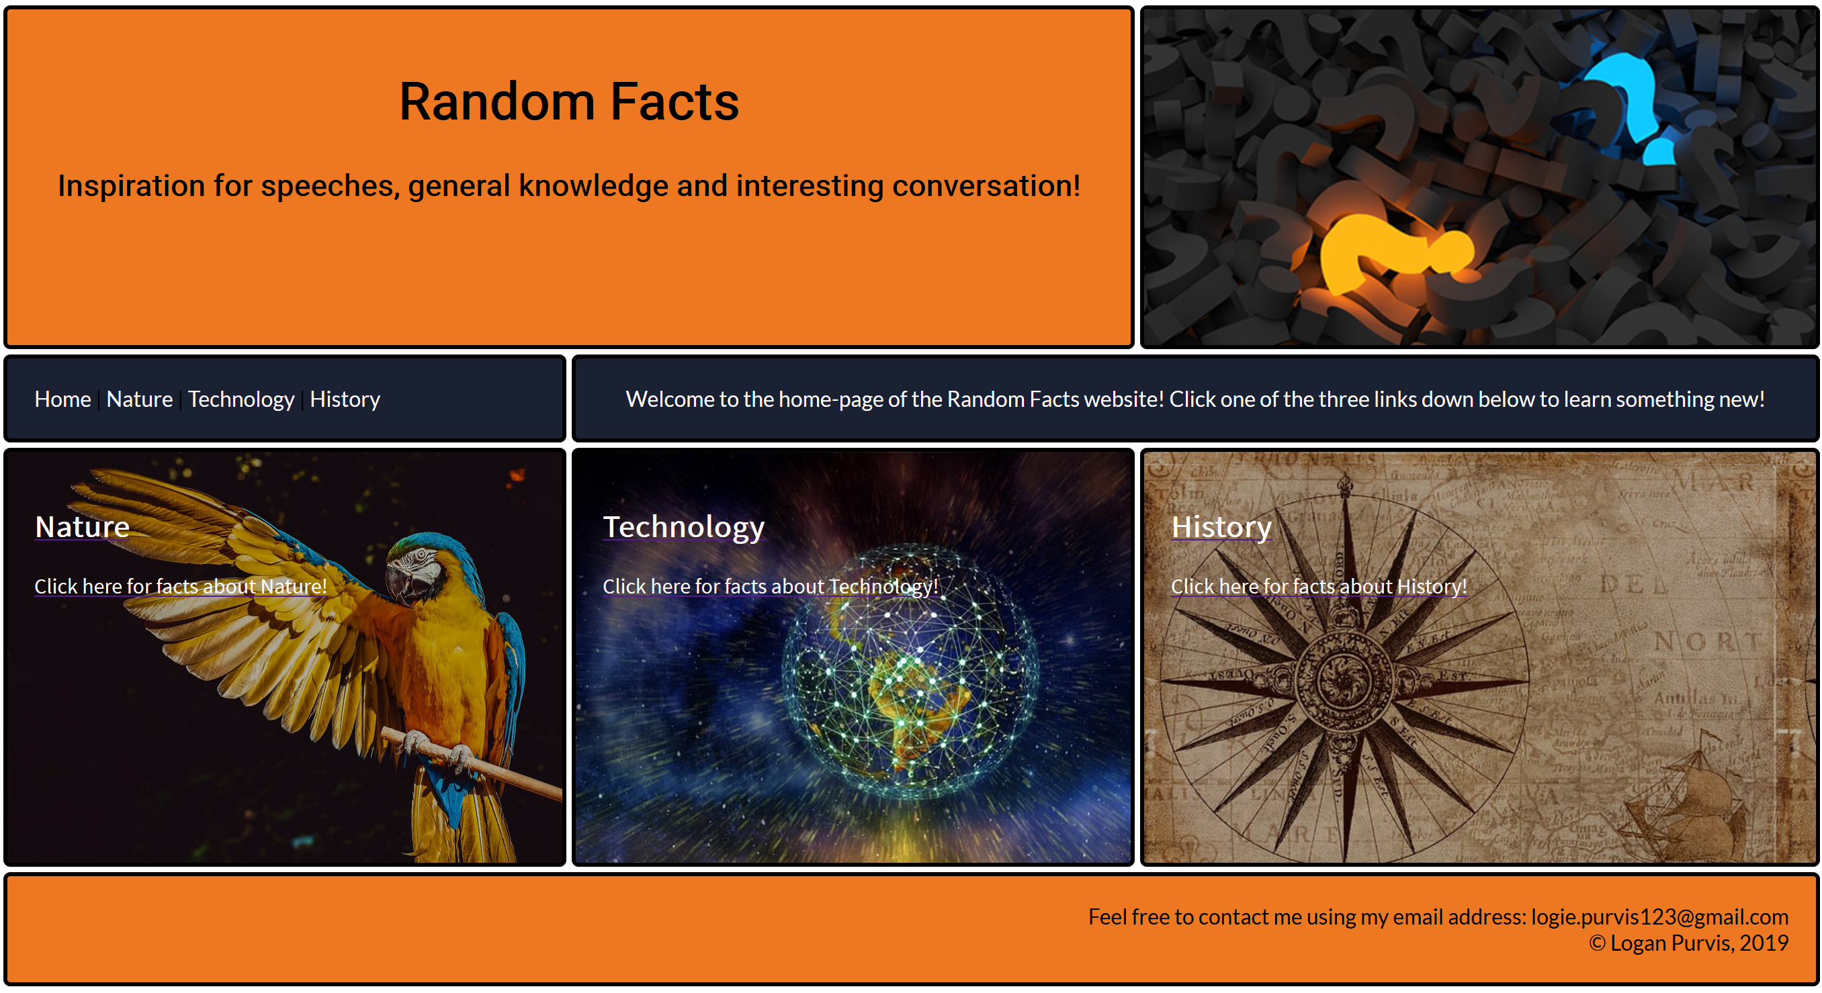

NATURE:

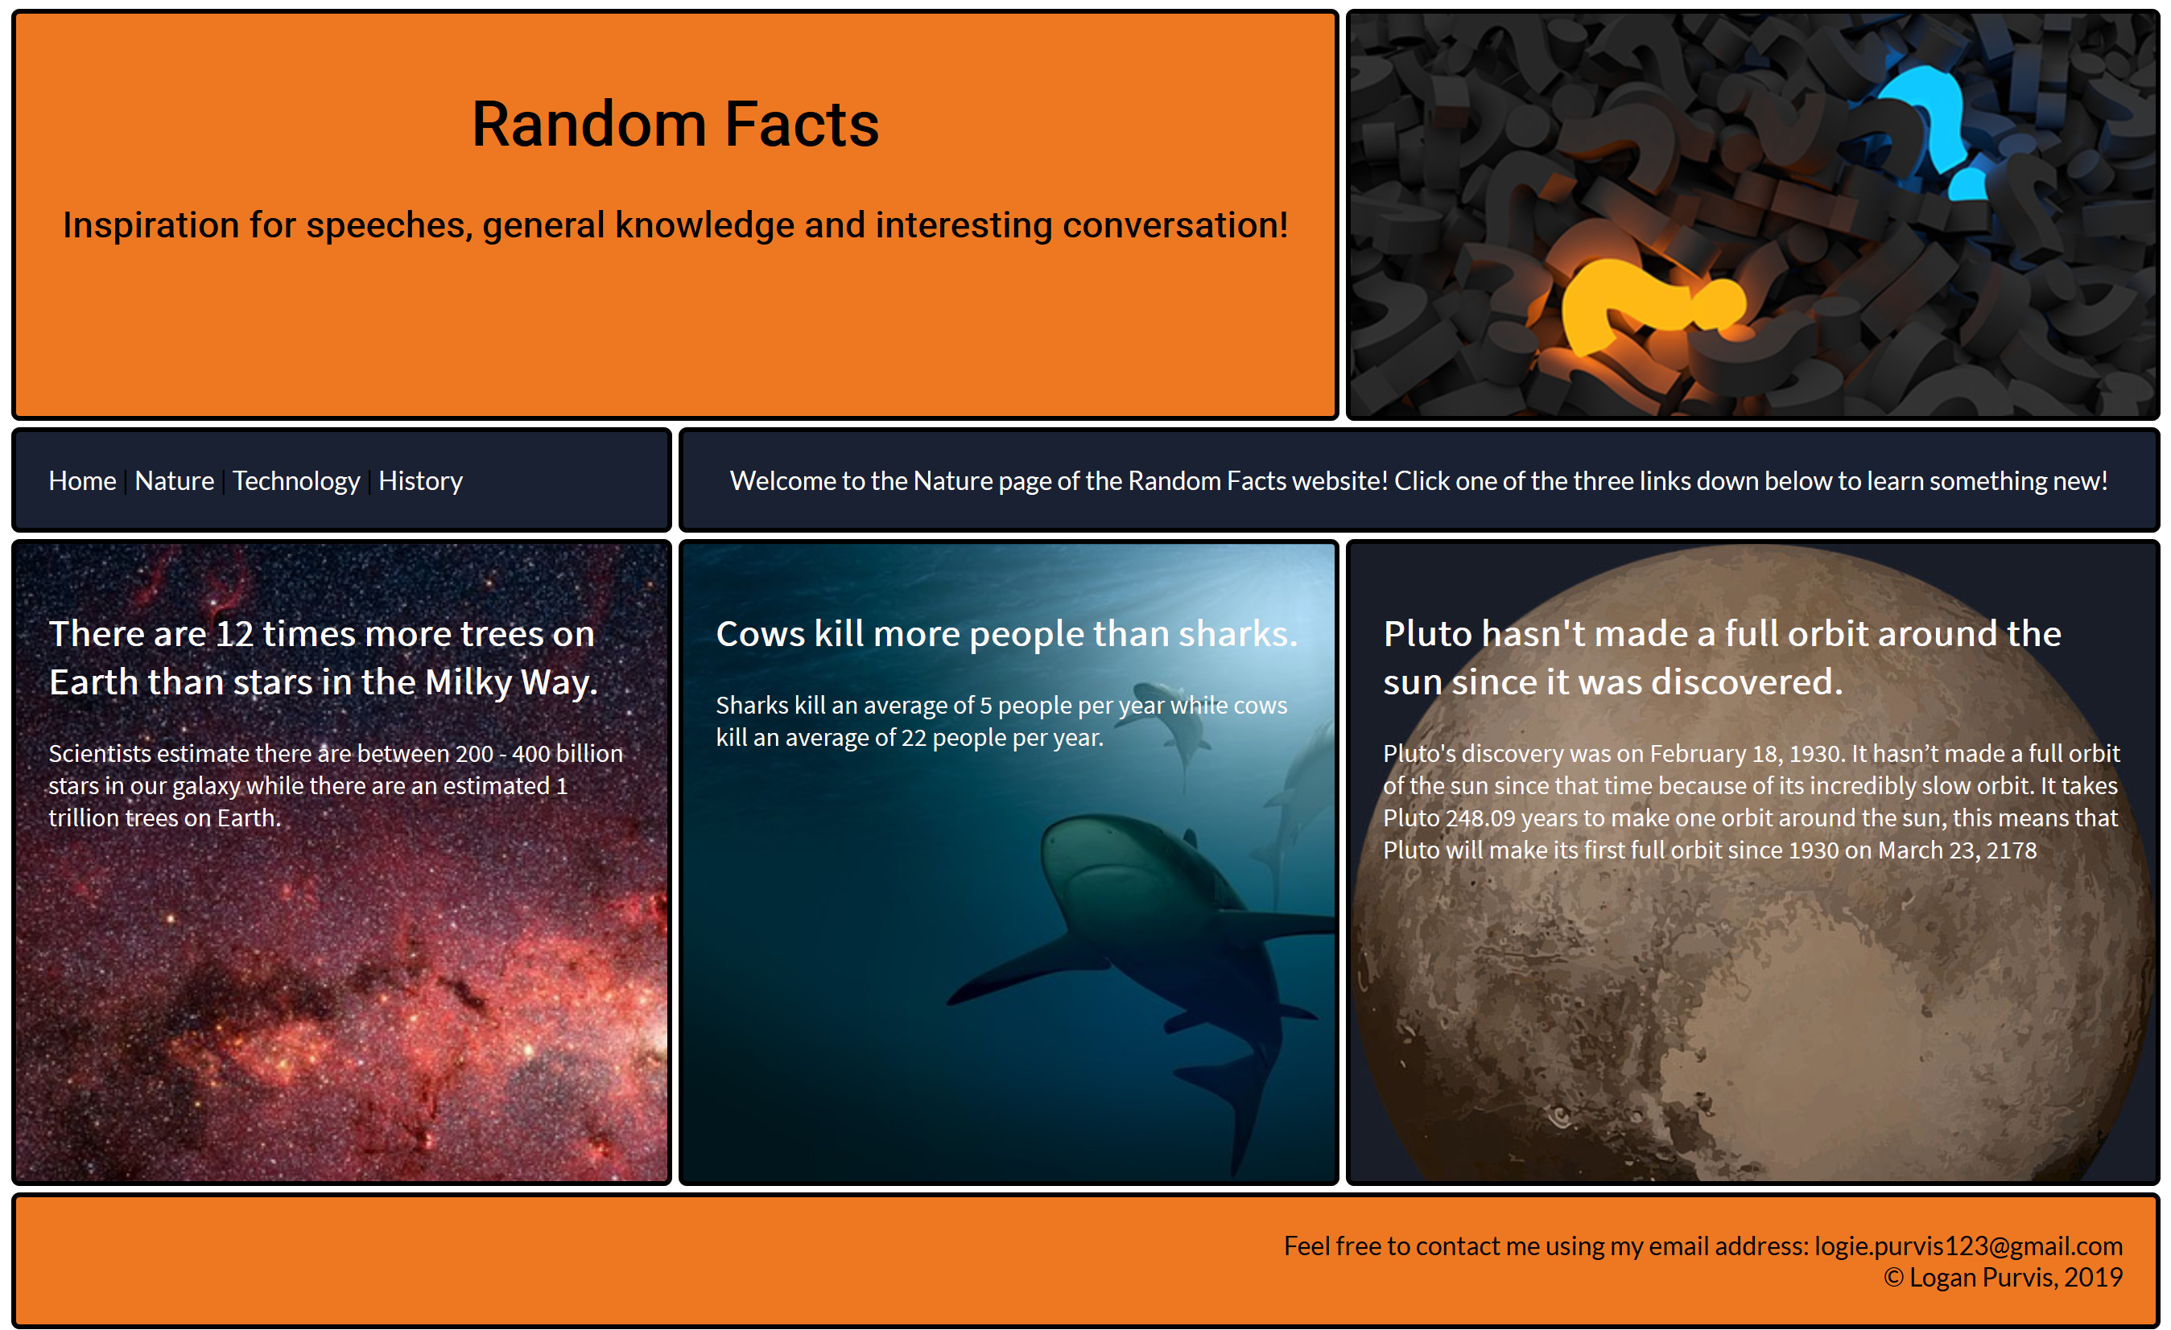

TECH:



HISTORY:

